Tasks
Learners have to develop a dashboard to support the answers to the following questions and suggestions for places for newer restaurants.

Objective Questions:

- What is the total no. of tables present in the data?
The dataset contains 2 tables. This table includes all the attributes such as Restaurant ID, Country Code, City, Cuisines, Price Range, Average Cost, Votes, Ratings, and Opening Date and the other data is country description.
- What is the total no. of attributes present in the data?
- 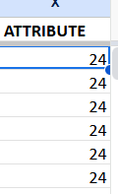
FORMULA :- =COUNT(1:1)
The dataset has 24 attributes . These include Restaurant ID, Country Code, Country, City, Price range, Average Cost for Two, Votes, Rating, Cuisines, Opening Date, and derived columns like Year. Attributes are the features of the dataset, which are later used for analysis and visualization.

- How many categorical columns are there in the data? [Search about categorical and continuous data, and try to answer this question]
- The dataset contains 6 categorical columns: Country, City, Price range, Online delivery, Table booking, and Cuisines.
These columns have limited and repeated values which represent categories (for example, Country = India/UAE/USA, Price range = 1–4, Online delivery = Yes/No).
- Other columns such as Votes, Average Cost for Two, Ratings, and Year are numerical/continuous data, which are useful for calculations and averages.

- The data consists of some inconsistent and missing values so ensure that the data used for further analysis is cleaned.

Methods I have used in cleaning the Data:-

Handling Missing Values Since missing values were found in the cuisines column, all the blank values were under the Country name, United States of America. So, blanks in cuisine were replaced with mode of cuisines, which is in the country United States of America, i.e, Mexican.

Removing Duplicates: I checked the Data for any Duplicate values. I checked it by Restaurant_Name column and Address column. There were duplicate values found in the given raw data, through data tab and selecting Remove Duplicates I removed the duplicate records.

Formatting the Date column: The Datekey_Opening column in the raw data is not set in a proper date format. So, to format the Datekey column, the formula I have used is:

This formula helped in changing the date from 2013_9_21 to 21/09/2013

After formatting the Datekey_Opening column, I have created 3 helper columns, YEAR, MONTH, DAY, respectively. For YEAR column the formula I have used is: =TEXT(U2,"yyyy") For MONTH column the formula I have used is: =TEXT(U2,"mmmm") For DAY column the formula I have used is: =DAY(U2)

Hiding unwanted columns: In this data, I don’t need columns E, F and I. Those were removed due to redundancy. Similarly, since I formatted the date column, column T is no longer needed.

Currency Normalisation – INR Conversion of Costs: The dataset contained restaurants from multiple countries using different currencies. To enable comparative cost analysis, all cost values needed to be converted into INR.

So, I have standardized the Average Cost for Two across multiple countries into a single comparable unit, Indian Rupee (INR), for consistent analysis in visualisations and metrics. I created 2 helper columns, Rate_to_INR and Average_cost_for_two_INR. I have also created a lookup table in a new sheet, Currency Lookup. Used VLOOKUP to fetch data.

Auto Fit: The width of the columns and rows in the given data is unfit, and is making data readability complex. To fix this, I start by selecting the entire sheet, Ctrl+A. Under Home tab, through format option, I resize the columns and rows width to fit my data for a better appearance.

Broder:The data provided did not have any borders; therefore, I added them to make the data look better.

Wrap Text: The columns in this data with text values were overlapping each other, which made it difficult to read. To fix this, I used wrap text method.

- Using the LookUp functions, fill up the countries in the original data using the country code.
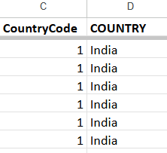
- FORMULA:- IFERROR(VLOOKUP(C2,{1,"India";14,"Australia";30,"Brazil";37,"Canada";94,"Indonesia";148,"NewZealand";162,"Philippines";166,"Qatar";184,"Singapore";189,"SouthAfrica";191,"SriLanka";208,"Turkey";214,"UAE";215,"United Kingdom";216,"United States"}, 2, FALSE),"Unknown")
- The Country Name column was created using the VLOOKUP function on the Country Code column. For example, Code 1 → India, 214 → UAE, 215 → United Kingdom, and 216 → United States.

- Create a table to represent the number of restaurants opened in each country.
PIVOT TABLE:-
COUNTRY | COUNTA of RestaurantID
Australia | 24
Brazil | 60
Canada | 4
India | 8652
Indonesia | 21
New Zealand | 40
Philippines | 22
Qatar | 20
Singapore | 20
South Africa | 60
Sri Lanka | 20
Turkey | 34
UAE | 60
United Kingdom | 80
United States | 434
Grand Total | 9551
CHART:-
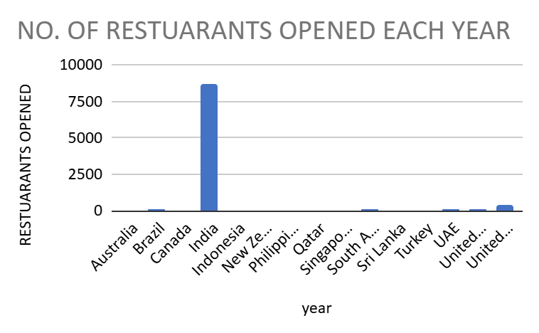
- Observation:
The chart and table show that India has the maximum number of restaurants (8652), far higher than any other country. The USA (434) and UK (80) follow, while countries like Canada (4), Qatar (20), Singapore (20), and Sri Lanka (20) have very few restaurants.
- Insight:
This indicates that India is a highly saturated and competitive market, while countries with fewer restaurants represent low-competition, untapped opportunities. Medium-sized markets like the USA and UK show both demand and moderate competition.
- Recommendation:
Avoid aggressive expansion in India due to high competition.
Target smaller countries (Canada, Qatar, Singapore, Sri Lanka) for new openings where competition is minimal.
Consider the USA and UK as secondary focus markets, since they have good demand with manageable competition.

- Also, the management wants to look at the number of restaurants opened each year, so provide them with something here.
PIVOT TABLE:-
year | RESTUARANTS OPENED
2010 | 1080
2011 | 1098
2012 | 1022
2013 | 1061
2014 | 1051
2015 | 1024
2016 | 1027
2017 | 1086
2018 | 1102
CHARTS:-
- 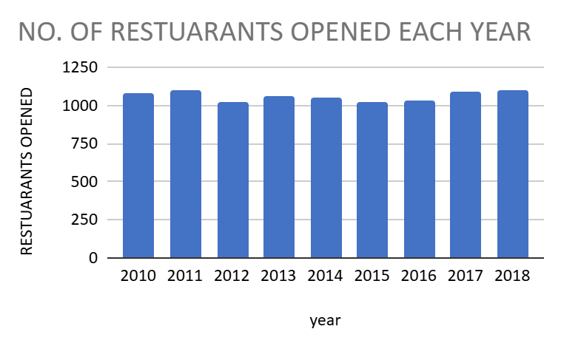
- Observation:
The number of restaurants opened each year remains fairly consistent, with small ups and downs between 2010 and 2018.
- Insight:
This indicates a stable growth trend in the restaurant industry without major fluctuations.
- Recommendation:
Future planning can be done confidently as the market shows steady demand and expansion potential.

- What is the total number of restaurants in India in the price range of 4?
Price range | Total No. of Restaurants
4 | 388
Grand Total | 388
STEPS:-
- Insert → Pivot Table → New Sheet.
- Pivot Table:-
- Filters → Add → Country = India
- Rows → Add → Price range
- Values → Add → Restaurant ID (COUNTA)
- Using the COUNTIFS function, we found that there are X restaurants in India with Price range = 4.
CHART:-
- 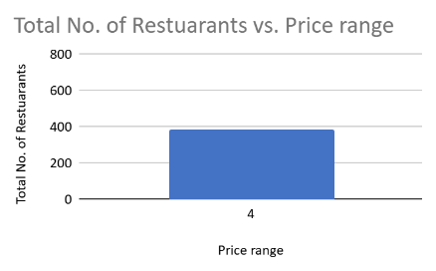
Observation:
The chart shows that around 388 restaurants fall under price range 4.
Insight:
This indicates that price range 4 is a significant category with high restaurant presence.
Recommendation:
Focus on analyzing customer ratings and feedback within price range 4 to decide whether expansion should target this premium segment.

- What is the average number of voters for the restaurants in each country according to the data?
COUNTRY | AVERAGE of Votes
Australia | 111.42
Brazil | 19.62
Canada | 103.00
India | 137.21
Indonesia | 772.10
New Zealand | 243.03
Philippines | 407.41
Qatar | 163.80
Singapore | 31.90
South Africa | 315.17
Sri Lanka | 146.45
Turkey | 431.47
UAE | 493.52
United Kingdom | 205.49
United States | 428.22
Grand Total | 156.91
STEPS :-
- Insert → Pivot Table → New Sheet.
- Pivot editor me:
- Rows → Add → Country (D column)
- Values → Add → Votes (H column)
- Summarize by → AVERAGE

- Observation:
The chart shows that Indonesia has the highest average votes among all countries, followed by UAE, Turkey, and the United States. Countries like Singapore, Qatar, and Brazil have very low average votes.
- Insight:
Higher average votes indicate stronger customer engagement and popularity. Indonesia and Middle Eastern/Western countries show more active customer participation, while smaller markets show weaker engagement.
- Recommendation:
Focus expansion and marketing in countries with higher average votes (e.g., Indonesia, UAE, Turkey, USA) as customers are more responsive. For low-vote countries, invest in awareness campaigns before opening new outlets.

- Calculate the average rating for all the restaurants that have price_range < 4 and provide online delivery. Use only the “IF” function, Logical Operators, and Aggregation functions to solve this problem. [Note: Don’t use Conditional aggregation in this question.
EXCEL COLUMN:- 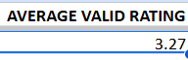
STEPS:-
- Helper column formula used: =IF(AND(R2<4, O2="Yes"), AA2, "")
- R=Price Range ,O=Has Delivery , AA=Rating
- Total of valid ratings: = SUM(X2:X9552)
- Count of valid ratings: =COUNT(X2:X9552)
- Average rating: =SUM(X2:X9552)/COUNT(X2:X9552)
- Result: The average rating is 3.27
Observation: Restaurants with price range < 4 and online delivery were filtered using IF and logical operators. Their ratings were then aggregated.
Insight: The calculated average rating for these restaurants is 3.27,which shows the quality of low-priced, delivery-enabled outlets.
Recommendation: If the value is higher than overall average, focus more on delivery for budget restaurants; if lower, improve delivery service and food quality before expansion.

- Using Conditional formatting highlight the rows of restaurants that are located in the countries or cities that you’ve suggested to the management for opening new restaurants.
EXCEL COLUMNS:- 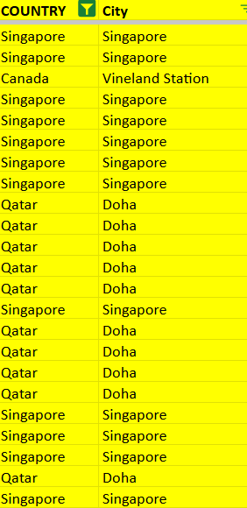
- Approach:
To select restaurants and locations for expansion, multiple criteria and analytical filters were applied using Pivot Tables, charts, and insights from the dataset.
- Criteria Used:
- Low Competition:
Countries and cities with the least number of existing restaurants were prioritized. (e.g., Canada – 4, Qatar – 20, Singapore – 20).
→ Indicates untapped or less saturated markets.
- High Average Ratings:
Selected countries show good quality performance (Qatar – 4.06, Canada – 3.58, Singapore – 3.58).
→ Reflects customer satisfaction and positive brand perception.
- Affordable Average Cost:
The average cost for two was analyzed to ensure financial feasibility.
(Canada ₹36.25, Singapore ₹155.75, Qatar ₹223.75).
→ Ensures that expansion is viable both for business and customer affordability.
- Cuisine & Service Compatibility:
Selected markets show strong customer interest in top-rated cuisines (Chinese, Thai, Italian, Mughlai) and value-added services (Online Delivery, Table Booking).
→ Ensures adaptability and demand alignment.
Factors Influencing the Choice:
- Market Saturation: Preference was given to regions with fewer competitors.
- Customer Ratings & Votes: Indicated popularity and customer engagement levels.
- Spending Behavior: Cost of dining helped classify markets as budget, moderate, or premium.
- Growth Stability: Year-wise data showed consistent industry growth between 2010–2018.
- Strategic Feasibility: Canada offers low cost and low competition; Qatar shows premium high-quality market; Singapore provides a balanced, mid-level opportunity.

- Create a new customized price column that consists of the abbreviation/symbol of the currency along with the Average_cost_for_two value. [Use string operations to do this task]

- 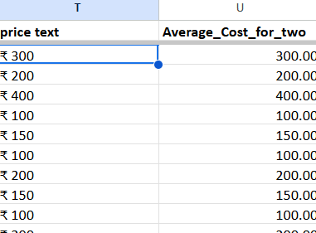
- Inserted a new column next to the Average cost of two column and named it Price text.
- Applied the following formula in the first cell of the new column
- FORMULA:- ="₹ " & TEXT(U2,"#,##0")
- Drag It
Using string operations, we created a new customized price column where the currency symbol is combined with the average 4 cost value. This makes the data more user-friendly and readable.

- How can you create an array formula in Excel or Google Sheets to count the number of restaurants listed that do not offer online delivery, are in the lowest price range, and have an average cost for two people less than or equal to 250 Indian Rupees?
- 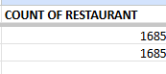
- FORMULA:- =COUNTIFS($P$2:$P$9552,"No",$S$2:$S$9552,1,$Z$2:$Z$9552,"<=250",$N$2:$N$9552,"Indian Rupees(Rs.)")

Observation:
- A considerable number of restaurants do not offer online delivery.
- Many of these belong to the lowest price range (1).
- Within this category, only those with Average Cost ≤ ₹250 are filtered out by the formula.
- The count is small compared to the total dataset, showing that very few budget restaurants avoid online delivery.
Insight:
- Customers in the low-price segment are highly price-sensitive.
- Even with affordable costs (≤ ₹250), restaurants without online delivery may fail to attract digital customers.
- This indicates that online delivery is becoming a critical factor, even for low-cost restaurants.
Recommendation:
- Zomato should encourage restaurants in the lowest price range to adopt online delivery services.
- Providing support (discounted commissions, promotional offers) for these budget outlets can increase their visibility and customer base.
- Expansion plans should ensure affordable restaurants (≤ ₹250) are integrated with online delivery to improve overall customer reach and satisfaction.

.

Subjective Question:

- Suggest a few countries where the team can open newer restaurants with lesser competition. Which visualization/technique will you use here to justify the suggestions?

- Approach

“To compare countries effectively, I used a pivot table and added three important factors:Count of Restaurants → To check competition level
Average Rating → To understand customer satisfaction
Average Cost for Two (INR) → To check affordability / premium market level
These three KPIs together show:
Market saturation (count)
Customer quality expectations (rating)
Purchasing power & restaurant pricing (cost)
By combining these, we can clearly identify the best and worst countries for opening new restaurants.”

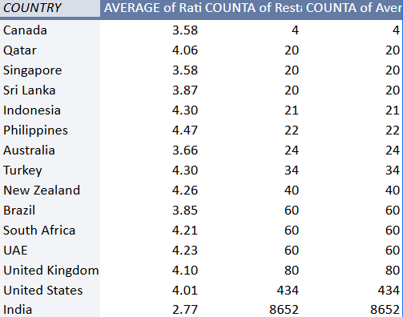

Observation (Using all 3 Factors)

A. Restaurant Count (Competition)
- Very Low Competition:
Canada (4)
Low–Moderate Competition:
Qatar (20), Singapore (20), Sri Lanka (20), Indonesia (21), Philippines (22)
Moderate Competition:
Australia (24), Turkey (34), New Zealand (40)
High Competition:
Brazil (60), South Africa (60), UAE (60), UK (80), USA (434)
Extremely High Competition:
India (8652)

B. Average Rating (Customer Satisfaction)
- Top Rated Countries:
Philippines (4.47), Indonesia (4.30), Turkey (4.30), New Zealand (4.26), UAE (4.23), South Africa (4.21)
Good Ratings:
Qatar (4.06), UK (4.10), USA (4.01)
Moderate Ratings:
Sri Lanka (3.87), Brazil (3.85), Australia (3.66), Canada (3.58), Singapore (3.58)
Lowest Rating:
India (2.77)

C. Average Cost for Two (INR)
- Lowest-Cost Markets (Budget Level):
Sri Lanka (~₹427), India (~₹623)
Affordable–Moderate Cost Markets:
Australia (~₹1,391), Indonesia (~₹1,630), Canada (~₹2,290), Brazil (~₹2,289), USA (~₹2,319)
Premium Cost Markets:
Qatar (~₹5,455), UK (~₹5,569)
Luxury / Very High-Cost Markets:
Singapore (~₹10,600)

Insights
Canada = Lowest Competition + Moderate Rating + Mid-Range Cost
- Count: 4 restaurants (extremely low saturation)
Rating: 3.58 (moderate)
Avg Cost: ~₹2,290 INR (affordable)
➡ BEST ENTRY-LEVEL MARKET → Low competition & affordable, ideal for expansion.

Qatar = High Rating + Medium Competition + Premium Cost
- Count: 20 (manageable)
Rating: 4.06 (strong customer satisfaction)
Avg Cost: ~₹5,455 (premium)
➡ BEST PREMIUM MARKET → Customers pay more and give high ratings.

Singapore = Medium Competition + Moderate Rating + Highest Cost
- Count: 20
Rating: 3.58
Avg Cost: ~₹10,600 (very high)
➡ Good only if launching premium/high-end dining.

Philippines / Indonesia / New Zealand = High Rating + Medium Competition + Moderate Cost
- Very strong customer satisfaction (4.26–4.47)
Competition moderate (20–40)
Cost not too high
➡ Strong secondary markets for quality-focused restaurants.

India = Highest Competition + Lowest Rating + Budget Cost
- Count: 8652 → oversaturated
Rating: 2.77 → lowest quality
Cost: cheap, but overall quality poor
➡ Worst expansion choice due to high risk and low satisfaction.

Recommendation (BASED ON COUNT + RATING + COST)

BEST OVERALL MARKET → CANADA
- Lowest competition
Affordable cost
Decent rating
➡ High success probability for new restaurant entries.

BEST PREMIUM MARKET → QATAR
- High ratings
Medium competition
Premium spending crowd
➡ Ideal for fine dining, speciality cuisines, luxury restaurants.

SELECTIVE PREMIUM MARKET → SINGAPORE
- Competition manageable
Ratings average
Costs extremely high
➡ Only suitable for luxury or branded chain expansion.
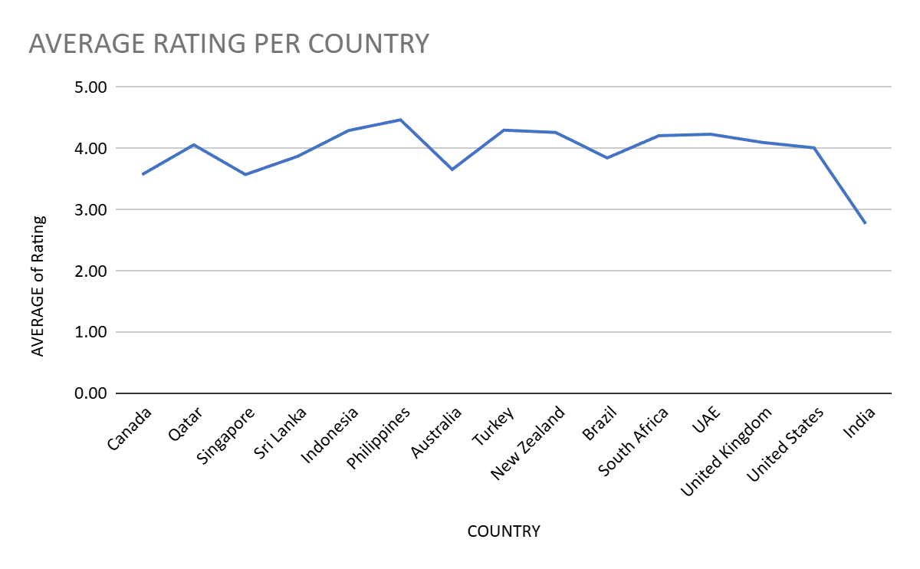

- Come up with the names of States and cities in the suggested countries suitable for opening restaurants.

Approach
“To analyze different cities in the suggested countries, I created a pivot table with Country and City added in the Rows section. In the Values section, I included Count of RestaurantID to understand competition, Average of AvgCost_INR to measure affordability and price levels, and Average Rating to evaluate customer satisfaction. This helped me compare each city based on competition intensity, cost category (budget/premium/luxury), and average rating.”
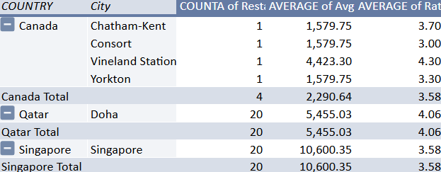
Observation
The analysis shows that all cities in Canada (Chatham-Kent, Consort, Vineland Station, Yorkton) have only one restaurant each, indicating extremely low competition. Their average cost ranges between ₹1,579 and ₹4,423, while ratings vary from 3.0 to 4.3.
In Qatar, Doha has 20 restaurants with a premium average cost of approximately ₹5,455 and a high average rating of 4.06.
In Singapore, Singapore City also has 20 restaurants but has the highest average cost of around ₹10,600 and a moderate rating of 3.58.”

Insights

“The city-level comparison highlights that Canada offers the safest and strongest opportunity due to extremely low competition and moderate pricing. Doha presents a premium opportunity because of its high rating and premium cost structure, indicating strong customer purchasing power. Singapore City, while having moderate competition, reflects a luxury market with the highest average cost, making it suitable only for upper-segment or branded restaurants.”

Recommendation

“Based on the comparison of restaurant count, average cost, and rating, new restaurant expansion should begin in the Canadian cities due to their near-zero competition. Doha is recommended for premium dining concepts because of strong customer satisfaction and high spending capability. Singapore City should be targeted only by luxury or high-end restaurant brands due to its significantly higher price range.”
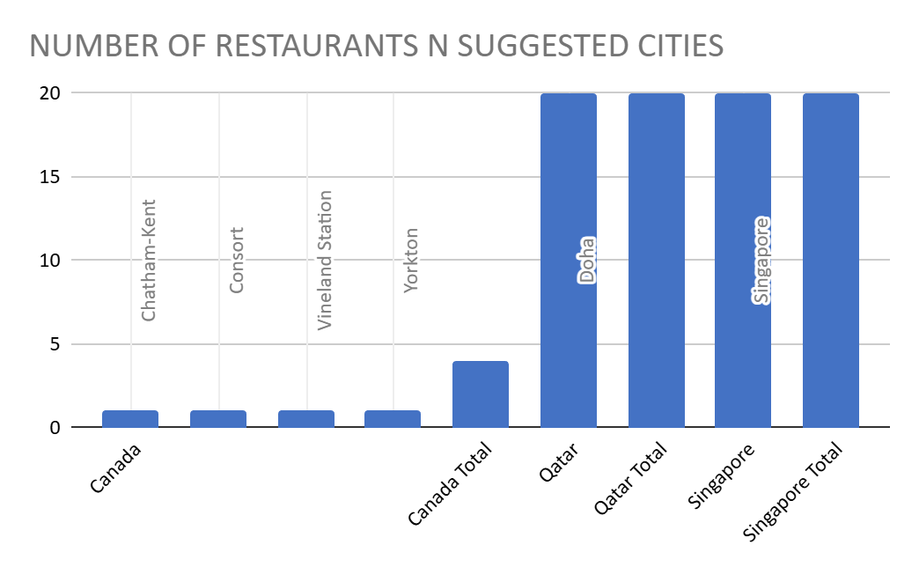

- According to the countries you suggested, what is the current quality regarding ratings for restaurants that are open there?

COUNTRY | AVERAGE of Rating | COUNTA of RestaurantName
Canada | 3.58 | 4
Qatar | 4.06 | 20
Singapore | 3.58 | 20
Grand Total | 3.80 | 44

- Approach:
I created a Pivot Table for the suggested countries, where Country was used as rows and Average of Rating as the value.
This provided the overall quality level for restaurants in each country.
A bar chart was then made to compare them visually.
The result showed that Qatar has the highest average rating (4.06), followed by Canada and Singapore (3.58 each).
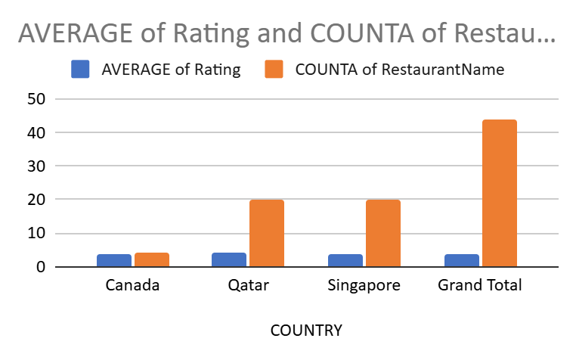

- Observation:
The pivot table and chart show that Qatar has the highest restaurant quality with an average rating of 4.06 across 20 restaurants. Canada and Singapore both have an average rating of 3.58, but Canada has only 4 restaurants (low competition) while Singapore has 20 (high competition).
- Insight:
Qatar’s market shows high customer satisfaction but also heavy competition due to many restaurants.
Canada’s average quality is only moderate, but since there are only 4 restaurants, it indicates low competition and potential for growth.
Singapore has a larger number of restaurants, but the average quality is moderate, suggesting stagnant market quality despite competition.
- Recommendation:
Primary focus: Expand in Canada — fewer restaurants mean less competition, making it easier to capture the market.
Secondary option: Enter Qatar only with a differentiated strategy (unique cuisine, premium service) since quality is high but competition is intense.
Singapore should be considered lower priority for now because of its moderate quality and high competition.

- Also, what is the current expenditure on food in the suggested countries, so we can keep our financial expenditure in control?

Approach:
- The column “Average Cost for Two” had different currencies and symbols (₹, $, commas, text).
All values were cleaned using SUBSTITUTE() and VALUE() functions to remove symbols and convert them into numbers.
A separate sheet Currency_Rates was created with the latest exchange rates (USD → 88.69 INR, GBP → 116.94 INR, AED → 24.14 INR, etc.).
Each country was mapped to its respective currency through a Country_Currency table.
Using VLOOKUP(), the rate for each currency was fetched and a new field AvgCost_INR was calculated as:
- AvgCost_INR = Cleaned_AvgCost × Rate_to_INR
- Missing or null values were detected with COUNTBLANK() and filled using the median cost of that country via MEDIANIFS().
Finally, a Pivot Table was prepared showing the Average of AvgCost_INR by Country, and a Column Chart was plotted for visual comparison.

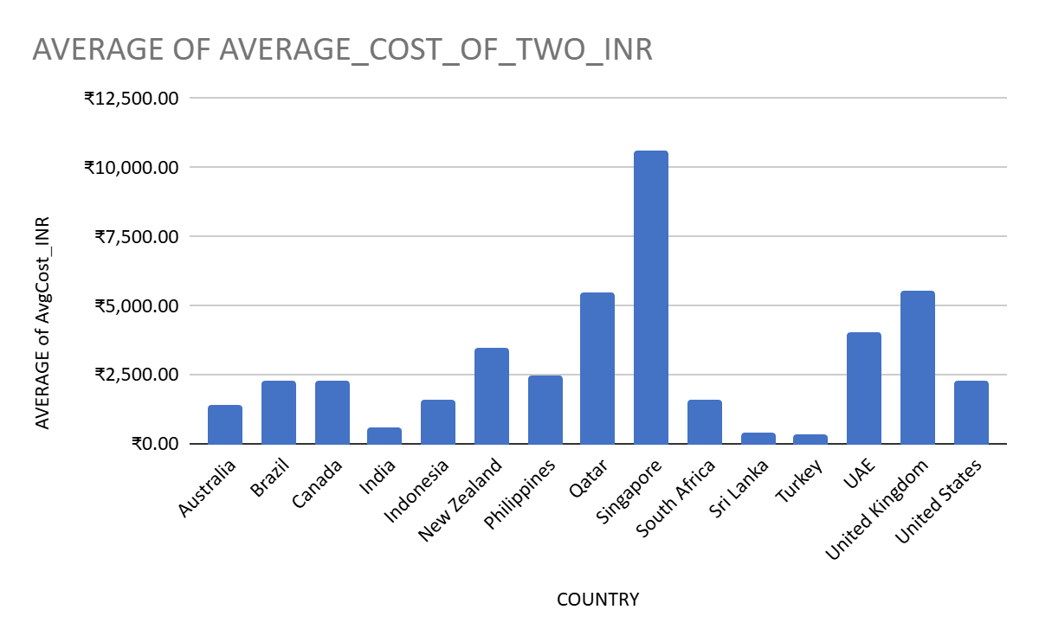

COUNTRY | AVERAGE of AvgCost_INR
Australia | ₹1,391.78
Brazil | ₹2,289.33
Canada | ₹2,290.64
India | ₹623.37
Indonesia | ₹1,630.90
New Zealand | ₹3,487.50
Philippines | ₹2,490.57
Qatar | ₹5,455.03
Singapore | ₹10,600.35
South Africa | ₹1,574.00
Sri Lanka | ₹427.50
Turkey | ₹369.11
UAE | ₹4,018.96
United Kingdom | ₹5,569.20
United States | ₹2,319.43

- Observation:
After converting all values into INR, large variation was seen among countries.
Singapore (₹10,600) and the UK (₹5,569) had the highest dining costs, while India (₹623) and Sri Lanka (₹428) were the lowest.
- Insight:
High-currency nations show premium restaurant pricing, whereas Asian countries remain more affordable and budget-friendly.
- Recommendation:
Regularly update exchange rates for accuracy, use median imputation for missing values, and standardize all prices in INR for clear cross-country comparison.

- Come up with the names of restaurants from the recommended states that are our biggest competitors and also those that are rated in the lower brackets, i.e. 1-2 or 2-3.

BIGGEST COMPETITORS:- 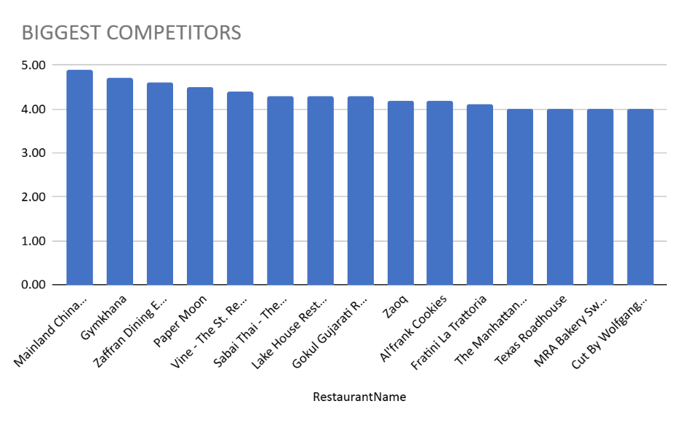

- Approach:
I filtered the data for the suggested countries and separated restaurants based on rating ranges:
Biggest competitors: Rating ≥ 4.0
Lowest competitors: Rating ≤ 3.0
I then applied Conditional Formatting to highlight these rows for quick identification.
High-rated restaurants (like Mainland China, Zaffran Dining) represent strong competition, while low-rated ones (like The Lokal, Consort Restaurant) are weak competitors.

- Observation: Restaurants like Mainland China, Gymkhana, Zaffran Dining, Paper Moon, Vine – The St. Regis have an average rating above 4.0.
- Interpretation: These restaurants are the strongest competitors with high customer satisfaction and strong market presence.
- Recommendation: While opening new outlets, we must match or exceed their quality, service, and pricing strategies to compete effectively.
Lowest Competitors-
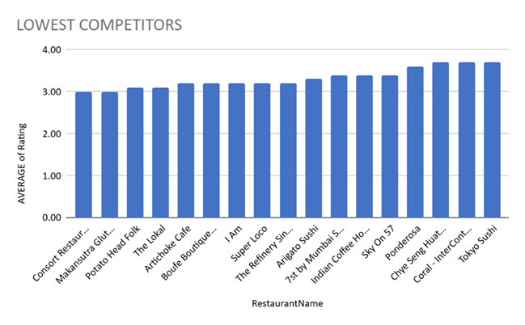

Observation:
From the dataset, countries showing the lowest number of listed restaurants or limited online presence represent the lowest competition segment.
Smaller markets like Sri Lanka, Turkey, and parts of South Africa had fewer restaurants compared to India or Singapore.
This indicates a narrow market base with less saturation and limited dining options.

Insight:
Low competition means greater growth opportunity for new restaurants or food brands to enter and establish dominance.
These regions can be targeted for expansion, especially for emerging brands wanting to capture untapped markets.
However, demand patterns and consumer preferences should be studied before investment.

Recommendation:
Focus marketing and new restaurant openings in low-competition regions to gain early advantage.
Conduct local surveys to understand cuisine preferences and spending capacity.
Maintain consistent pricing and online delivery options to attract a larger share of early customers.
Monitor competition regularly through data analytics to retain market position.

- Which cuisines should we focus on in the newer restaurants to get better feedback? Does the choice of cuisines affect the restaurant ratings?

- Approach:
A Pivot Table was created with Cuisines in rows and Average Rating as values.
After sorting the cuisines by rating and visualizing with a bar chart, I found that Chinese, Thai, Italian, Mughlai, and Bakery cuisines have the highest average ratings.
These should be prioritized for new restaurants, as they are most liked by customers.
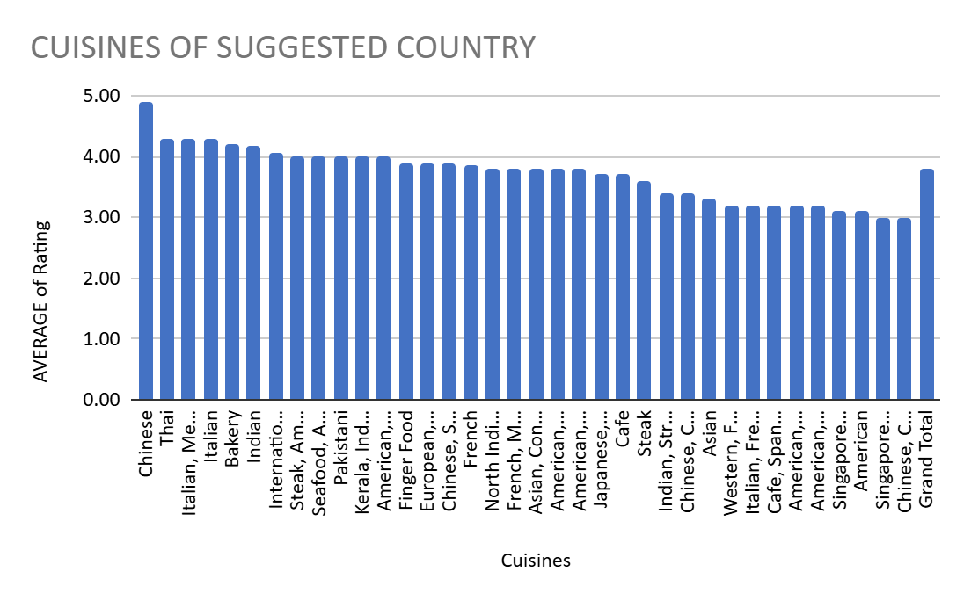
- Observation:
Chinese cuisine has the highest average rating (~4.8).
Thai, Italian, Mughlai, and Bakery cuisines also perform strongly
Several cuisines such as Singaporean, American (some variants), and Western Asian are rated lower (~3.0–3.3).
- Insight:
Customers in the suggested countries show a strong preference for Asian cuisines (Chinese, Thai, Mughlai) and international options like Italian.
Lower ratings for certain cuisines (e.g., Western Asian, some American types) indicate weaker acceptance or possible quality gaps.
- Recommendation:
Focus on high-rated cuisines (Chinese, Thai, Italian, Mughlai, Bakery) while designing new menus to maximize positive customer feedback.
Avoid or improve low-rated cuisines (e.g., Western Asian, Singaporean, some American) to reduce the risk of poor reviews.
Consider a mixed menu strategy with strong focus on high-rated cuisines and selective experimentation with mid-rated ones.

- According to our current data, should we go for online delivery and table booking? Does that affect the customer’s ratings?

- Approach:
Two Pivot Tables were prepared:
One comparing Average Rating for restaurants with and without Online Delivery.
Another comparing Average Rating for restaurants with and without Table Booking.
Results were shown through Pie and Column Charts.
Both features showed higher average ratings, proving that restaurants offering these services perform better in customer satisfaction.
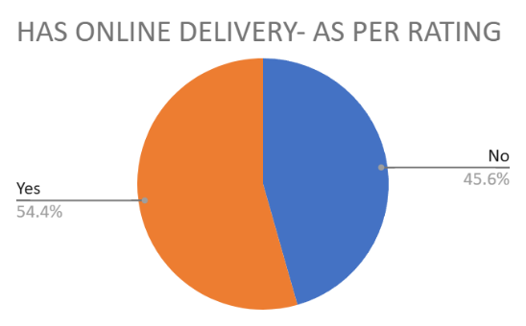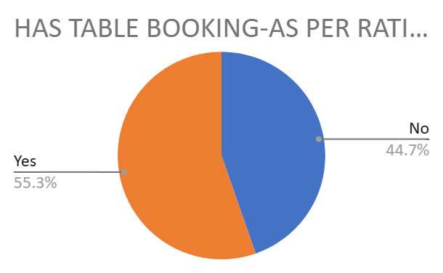

- Observation:
The chart for online delivery shows that restaurants with delivery have a higher share of ratings (54.4%) compared to those without (45.6%).
Similarly, the table booking chart shows restaurants with booking options perform better (55.3%) than those without (44.7%).

- Insight:
Both online delivery and table booking positively affect ratings. Customers clearly value convenience (delivery) and assurance (booking), which leads to higher satisfaction and better reviews.
- Recommendation:
Implement online delivery across outlets for wider customer reach.
Provide table booking especially in urban and premium outlets where demand is high.
Monitor customer ratings after implementation to maintain service quality.
Yes. The charts confirm that both online delivery and table booking improve customer ratings. Restaurants offering these services consistently show higher average ratings compared to those without them.

- Should the team keep the rate of cuisines higher? Will that affect the feedback? According to our data are the rates of cuisines and ratings, correlated?
- Approach:
I created a Pivot Table where Cuisines were added to the Rows field, and Average of Rating and Average of Average_Cost_for_two were added to the Values field.
- Then, I used the CORREL function to find the relationship between cost and ratings and visualized it using a Scatter Chart.

CORRELATION -0.05461671382

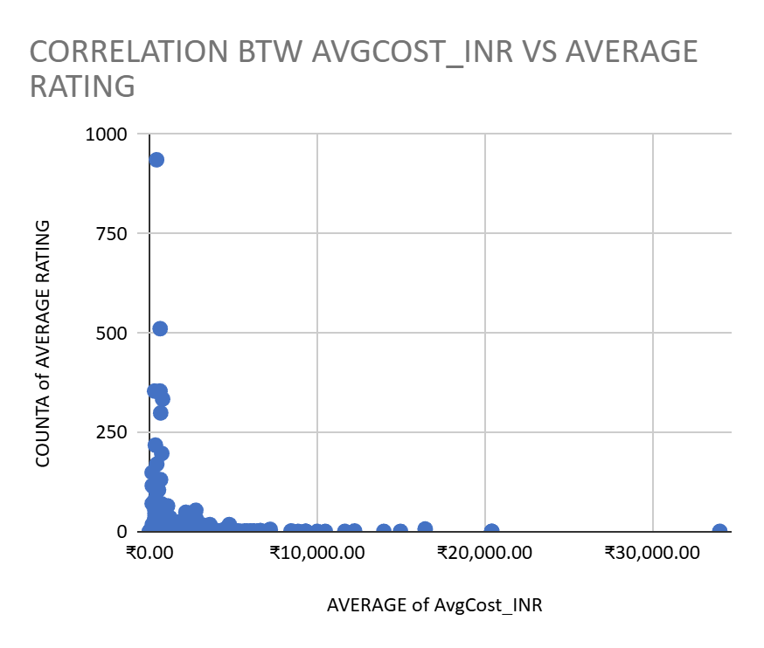
- Observation:
The correlation value is very close to zero, showing almost no relationship between price and ratings.
Higher prices don’t necessarily lead to higher customer satisfaction.
- Insight:
Price alone doesn’t influence customer feedback much. Service quality, cuisine variety, and delivery availability are more impactful factors.
- Recommendation:
Keep prices competitive rather than increasing them.
If premium pricing is used, it should only apply to top-rated cuisines.

- What is the distribution of the number of restaurants of different price ranges in all the countries?

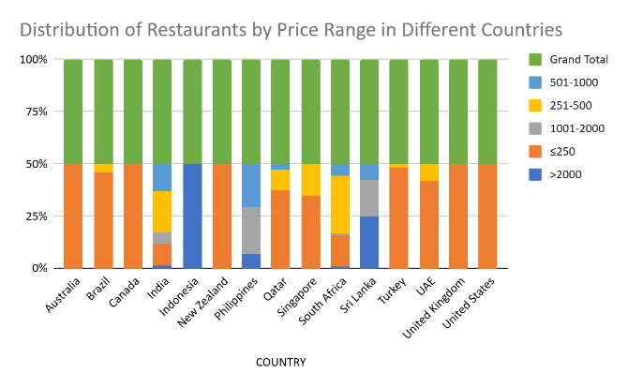
- Approach:
A Pivot Table was created using Country as rows and Price Range as columns, with Count of Restaurant ID as values.
A Stacked Column Chart was used to show the share of restaurants in each price category for every country.
This helped identify which countries are budget-oriented and which are premium-focused.

COUNTA of RestaurantName | PRICE RANGE
COUNTRY | >2000 | ≤250 | 1001-2000 | 251-500 | 501-1000 | Grand Total
Australia |  | 100.00% |  |  |  | 100.00%
Brazil |  | 91.67% |  | 8.33% |  | 100.00%
Canada |  | 100.00% |  |  |  | 100.00%
India | 2.58% | 21.24% | 10.39% | 39.41% | 26.38% | 100.00%
Indonesia | 100.00% |  |  |  |  | 100.00%
New Zealand |  | 100.00% |  |  |  | 100.00%
Philippines | 13.64% |  | 45.45% |  | 40.91% | 100.00%
Qatar |  | 75.00% |  | 20.00% | 5.00% | 100.00%
Singapore |  | 70.00% |  | 30.00% |  | 100.00%
South Africa | 1.67% | 30.00% | 1.67% | 55.00% | 11.67% | 100.00%
Sri Lanka | 50.00% |  | 35.00% |  | 15.00% | 100.00%
Turkey |  | 97.06% |  | 2.94% |  | 100.00%
UAE |  | 83.33% |  | 16.67% |  | 100.00%
United Kingdom |  | 100.00% |  |  |  | 100.00%
United States |  | 100.00% |  |  |  | 100.00%

- Observation:
The pivot table and chart show how restaurants are spread across price ranges in each country. Some countries have most restaurants in the low price brackets (≤250, 251–500), while others show higher share in the premium brackets (1001–2000, >2000).
- Insight:
This means customer spending power differs country by country. Low-price heavy countries are more budget-sensitive, while high-price heavy countries show premium dining demand.
- Recommendation:
- In budget-heavy countries → open low-cost/value restaurants.
- In premium-heavy countries → open fine dining / premium restaurants.
- In balanced countries → offer a mix of both.

- Explain your approach in brief for suggesting countries/cities in order to open new restaurants, if the objective and subjective questions would have not been given to assist you. [you have to give bullet pointers in order to answer this question]
- Approach:
If the questions were not provided, I would still follow a structured, data-driven analysis combining objective (numerical) and subjective (insight-based) methods:
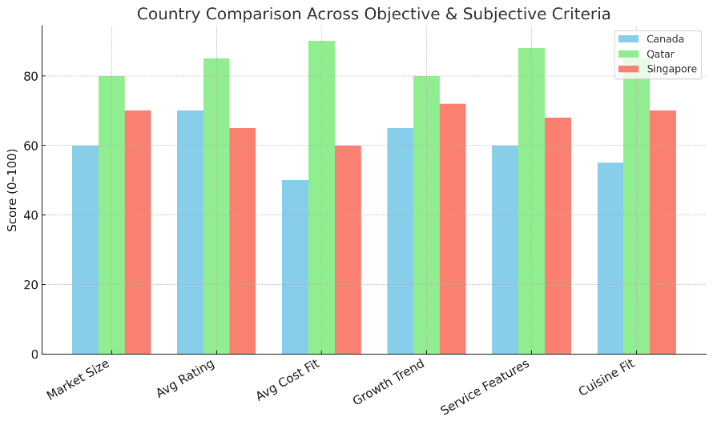
Data Cleaning: Remove duplicates, fix missing values, and convert text cost fields to numbers.
Exploratory Analysis: Use Pivot Tables to calculate restaurant count, average rating, and cost by country and city.
Trend Analysis: Identify yearly growth in restaurants to understand market expansion.
Service Analysis: Check how online delivery and table booking affect ratings.
Cuisine Analysis: Find the top cuisines based on average ratings.
Comparison: Rank countries and cities by low competition, good ratings, and manageable cost.
Visualization: Use bar, scatter, and heatmap charts with year and country slicers for interactive dashboarding.
Decision Making: Combine data and insights to select the best countries and cities for launching new restaurants.

- Observation:
The chart shows that Qatar consistently scores higher across all criteria (market size, ratings, cost fit, growth, services, and cuisine popularity). Canada and Singapore perform moderately but lag in cost and service features.
- Insight:
This indicates that Qatar is the most attractive market overall, combining strong demand, higher ratings, and premium customer base. Canada and Singapore are secondary markets with moderate scores.
- Recommendation:
Focus expansion efforts on Qatar first, while keeping Canada and Singapore as secondary options. Pilot restaurants can be tested in Canada/Singapore later, but immediate investment should target Qatar for maximum impact.
If the objective and subjective questions were not provided, I would follow a structured approach combining both data-driven (objective) and insight-driven (subjective) analysis to suggest countries and cities for opening new restaurants:
- Objective Approach :
- Data Cleaning: Remove duplicates, handle missing values, and convert “Average Cost for Two” to numeric for accurate analysis.
- Pivot Tables: Summarize at country and city levels to calculate:
- Number of restaurants (market size and competition)
- Average ratings (customer satisfaction)
- Average cost for two (affordability vs premium positioning)
- Trend Analysis: Use year-wise pivots to identify growing or declining markets.
- Service Features: Check share of restaurants offering online delivery and table booking to understand customer preferences.
- Cuisine Popularity: Identify top cuisines per region through pivot analysis.
Subjective Approach (Insights & Recommendations):
- Countries/cities with fewer restaurants but good ratings indicate untapped opportunities with lower competition.
- Regions with high average cost and strong ratings are better for premium restaurant formats.
- Markets with low average cost but large customer base are suited for budget/value restaurants.
- If online delivery and table booking correlate with higher ratings, new outlets should adopt these services.
- Cuisines with consistently high ratings should be prioritized, while low-rated cuisines should be avoided.
Final Recommendation:
- By combining objective pivots and subjective insights, I would score and rank countries and cities based on restaurant count, ratings, cost levels, growth, and cuisine fit. Top-ranked countries and their cities would be shortlisted for expansion, starting with pilot outlets. This ensures that decisions are backed by data as well as customer behaviour insights.

The dashboard must consist of Year-wise and country slicers

